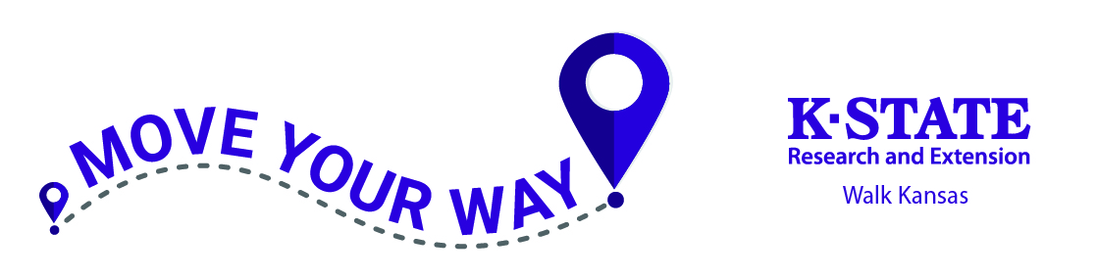
Are you ready?

Wow, what a year we have been through. As we planned for and launched Walk Kansas 2020, K-State Research and Extension was temporarily closing offices to the public and pausing all face-to-face programming. Walk Kansas continued with complete virtual delivery. We have learned a lot since then. We have adapted, as you have, to new ways of working, learning and thriving. So, welcome to Walk Kansas 2021!! Most, if not all, of this program will take place through virtual delivery. Be sure to check out what your local office is providing for you, and tune in when you can to opportunities offered state-wide from K-State Research and Extension on campus.

Online registration is now open. Information about the program, helpful resources, and a link to register is available at www.walkkansas.org.

Welcome to Walk Kansas 2021!! This year, we will take a close look at how physical activity plays an important role in managing, delaying and even preventing some types of chronic disease. Specifically, we will explore mental health, heart disease, osteoporosis, Alzheimer’s, obesity, arthritis, diabetes and cancer.

Weekly newsletters, social media posts, noon-hour webinars and more will provide information, and the inspiration, for you to Move Your Way, Make Every Bite Count, and reduce chronic disease. Now, it’s time for you to gather your team and get ready!

Here is a step-by-step guide that covers options for registering your team followed by general program information.

Register online:
▪ Before you go to register, recruit team members (at least 4 – you can add more later). You will need their email address, or mailing address if they do not have email. When you register your team, you will be asked to pay for the number of people participating ($10/person), so be prepared to pay with credit card (PayPal) or follow up by sending a check.
▪ Talk with your team and select a goal based on how many minutes of exercise each person will commit to per week – 2 ½ hours, 4 hours or 6 hours.
▪ When you have this information you are ready to register online at www.walkkansas.org. If you reach a point during the process where you don’t have the needed information, click CANCEL and start again later. (Please do not exit out of the system without selecting CANCEL.)

Captain Guide March 28 – May 22. 2021
Kansas State University Agricultural Experiment Station and Cooperative Extension Service
K-State Research and Extension is an equal opportunity provider and employer.
Important dates:

March 8 – Online registration open

April 2 – Registration closes

March 28 – Go! Log exercise minutes and cups of fruits/vegetables

April 12 – Last day to order Walk Kansas apparel

May 22 – Walk Kansas wraps up!

If you have any state of Kansas employees on your team, who are working to earn Health Quest credit, the participation fee is waived. These employees can earn 4 HQ credits and you will need to request a discount code from your local office, or from sharolyn@ksu.edu, to apply at checkout.
Time to get registered!
- Click the yellow “Register” button
- Ready to Go! (Notice the link that will help you locate all KSRE offices in Kansas.)
- Select the county or district where you will participate
- Pick your Challenge. You have 3 options based on the goals your team goals: “8 Wonders Walk” = 2 ½ hrs/wk; “Cross Country” = 4 hrs/wk; “Little Balkans to Nicodemus” – 6 hr/wk (New in 2021 – A Solo Challenge Trail. This is for those who choose to participate as an individual, rather than part of a team.)
- Choose “Captain” since you are registering a team.
- Enter the name of your team. (You can change the name later.)
- Create your personal user account. Select a username and password; then complete the required personal information.
- Now you are ready to build your team. Complete the required information for at least 4 people. Then confirm your team.
- Complete the next page by giving your consent to participate. You must consent and choose from the authorization statements to continue. Note: Each team member that you entered will receive a message asking them to create a user profile and consent. Each person must do this before your team is ready to go.
- Order Summary and Checkout – pay online or select “Pay with Check” and follow up with your payment.
- Congratulations – you are registered for Walk Kansas! Please not the name(s) of your local Extension Agent(s) and/or program coordinators if you have further questions.

Apparel Orders for 2021
The process for ordering t-shirts, and other apparel, has changed. After you complete registration, you can log in to your portal. On the purple bar at the top, click on the “Shop” button. This will take you to our apparel vendor site, www.shopwalkkansas.com and you can place your order. Unlike previous years, you will be required to pay shipping and the items will be shipped directly to you. Please note the dates for placing orders.

Register with paper forms:
▪ Distribute participant information to each team member.
▪ Select a team challenge and complete the Team Registration Form (available from your local Extension Office.)
▪ Collect registration forms and program fees. Return forms and payment (one check per team) to the Extension Office before ____(insert date)____. Registration is not complete until all forms are collected and fees are paid. T-shirts and other apparel can be ordered at www.shopwalkkansas.com or contact your local office.
Ready to go!
Reporting/logging online:
Once your team is “ready” (everyone has added user information, consented and all fees are paid) you will see a screen like this when you log in. Encourage your team to use “team chat” to communicate and to load photos. You will record your personal exercise minutes, fruits/veg here and you can also view how others on your team are doing by clicking on “My Team.” Check for “Events” in your area and “Resources” located on the top bar. NOTE: The colorful boxes where you log minutes, etc. will not appear in your dashboard until your team is “ready” – all fees have been paid and all participants have completed the consent form. You will not be able to start logging until March 28, the first day of Walk Kansas.
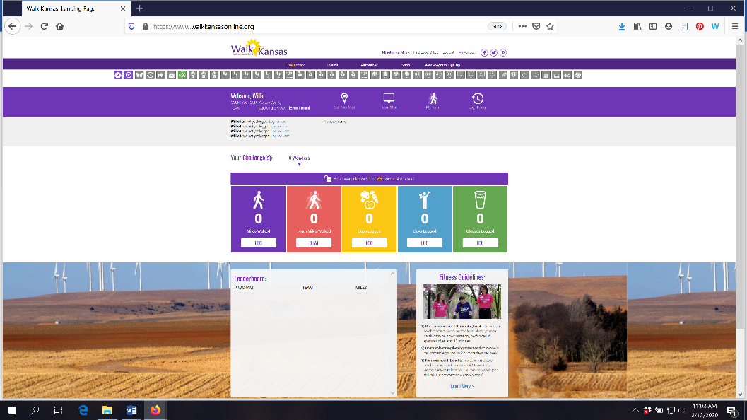

Make sure you and your team-mates check your progress on the map – click “See Your Map” on the large purple bar. As your team moves along the trail you will unlock points of interest. Some will have photos and all have a description of the town/community, area of interest, or Wonders of Kansas. You can go back and click on any dot you have passed through to read the information. Enjoy!! This year, captains will also have the option to switch your team to a different trail/challenge if you reach the end of your trail before Walk Kansas is over. Captains will receive a prompt and are the only ones that can move the team to another trail. The miles your team was gone will continue with you to the new trail OR you can select another option for your team to keep going.

Scroll down a bit further and you will see a “Leaderboard” at the bottom. Here you can view how other teams in your county/district are doing.
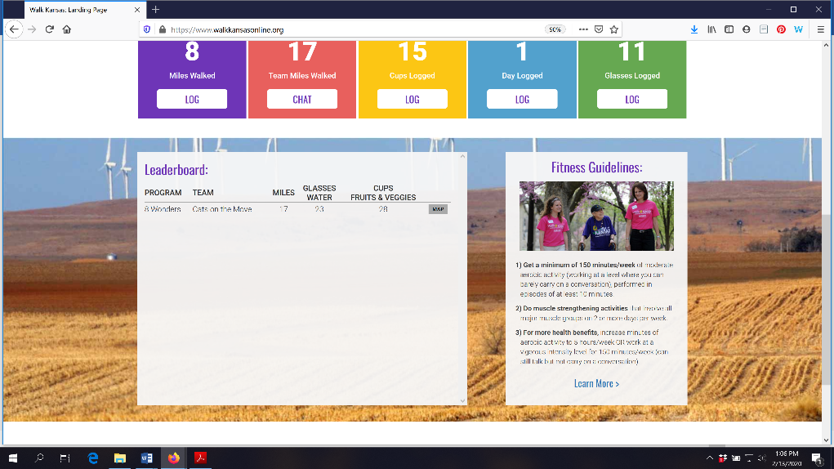

You can also view how teams in any county/district across the state are doing through the blue “Leaderboard” button on the login page.
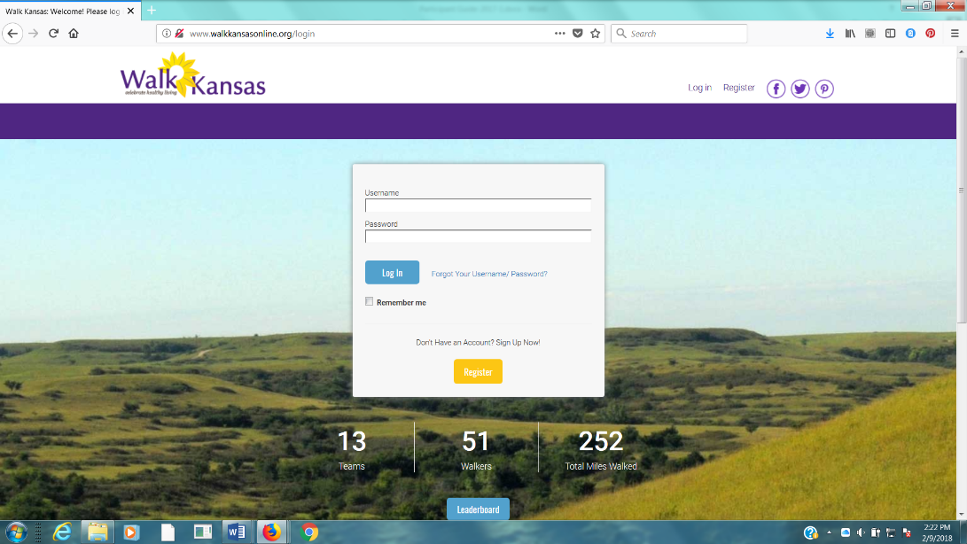

Reporting if logging by paper:
If team mates log on paper and report to you weekly, add totals once a week for that person by clicking on their name just below the purple bar on the left side. If you want to report only one number (total minutes of activity) for your entire team, report it as minutes for you – the captain – only.

Reminders for captains:
► Communicate with your team mates each week (email, chat in Walk KS system, phone call or in person.) All Walk Kansas participants will receive a message on Wednesday of each week that includes a short report of how their team is doing. Everyone will also receive a weekly newsletter.
► Make sure team-mates are receiving a weekly Walk Kansas newsletter. If not, report this to your local office. (Newsletters will also be posted in the “Resources” section. Top dark purple bar)
► Stay informed of events and activities offered in your community and participate when you can!
► Plan a fun activity(s) your team can do together during the 8 weeks of Walk Kansas.

Captains also participate:
Not only are you the captain of your team, you are a Walk Kansas participant! Make sure you read through the participant materials, including the Activity Guide. There is information here about pre/post fitness tests that your team may want to do and this is an activity you could do together. These are optional and can be very helpful and motivating. Make sure you also review what counts as Walk Kansas minutes in the Activity Guide.

While Walk Kansas is sometimes viewed as a (friendly) competition, reaching the goal your team has selected is the most important. Be realistic, keep it fun and don’t worry about what others are doing or reporting. Be honest, be supportive to others and have a great Walk Kansas!!

Walk Kansas App:
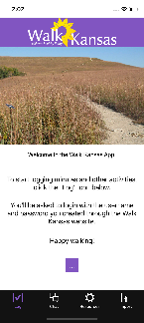
Right now, the Walk Kansas app is available only in iOS format, for iPhone and iPad. You can log (but not register) through the app and use this to navigate other features of the online system. The app is free and it is available through the App Store. If you have a fitness tracker, data from your tracker should sync with the app. The only exception is if you have a Fitbit. You will need to download Fitbit to Apple Health Sync ($5.99) from the App Store for this data transfer.
Using the Walk Kansas app:
- Before you use the app make sure your team is created online, that you have selected a challenge (from the 3 available), and make sure that logging is ready to go and that your team is ready. You may want to test this online first to make sure you can log minutes.
- When you open the app for the first time, you’ll see a splash screen that tells you to login with the username and password you created on the WK website. When you close this screen you will see some login fields.
- After you login, the default screen should be the log activity screen ; click “new log” and have at it!
- To edit an existing log just click the row you want to edit. All data entered through the app will transfer to the web and vice versa.

